Revolving Loan Program
Establish a revolving loan fund through an institution or other partnership that provides low interest loans to affordable housing projects citywide to address needs. Establish criteria for the loans that support other goals such as proximity to transit and sustainability.

What we heard
- Economic activity in Oakland and adjacent areas has been instrumental in keeping Pittsburgh, and to some extent Western Pennsylvania, competitive and successful when other US cities with similar legacy industries saw much more significant hardship. In particular, the growth of research and development activities, life sciences, and healthcare are massive sectors that are growing exponentially.
- These sectors are also attracting investment and residents from throughout the country and the world.
- Like many cities, Pittsburgh is suffering from rapid growth in housing costs with no commensurate growth in pay.
- As data from this planning process confirms, the lowest paid employees in Oakland often travel the furthest to work in order to utilize lower cost housing further out in the region.
- Further, Oakland has been losing its African-American residents for decades. This could be for many reasons, but housing cost is surely part of the driving forces.
- The result is what some have called a “housing crisis” that affects where employees can afford to live, transportation decisions, and has led to displacement of low income residents.
- These problems are exacerbated in Oakland where student housing demand far outstrips the housing supply or what the market has been able to produce.
- The result is a housing problem that risks undermining the continued competitiveness and growth of our region if not adequately addressed.

When to start
0-2 years

Duration
Ongoing

Estimated costs
$$$$

Illustration(s)
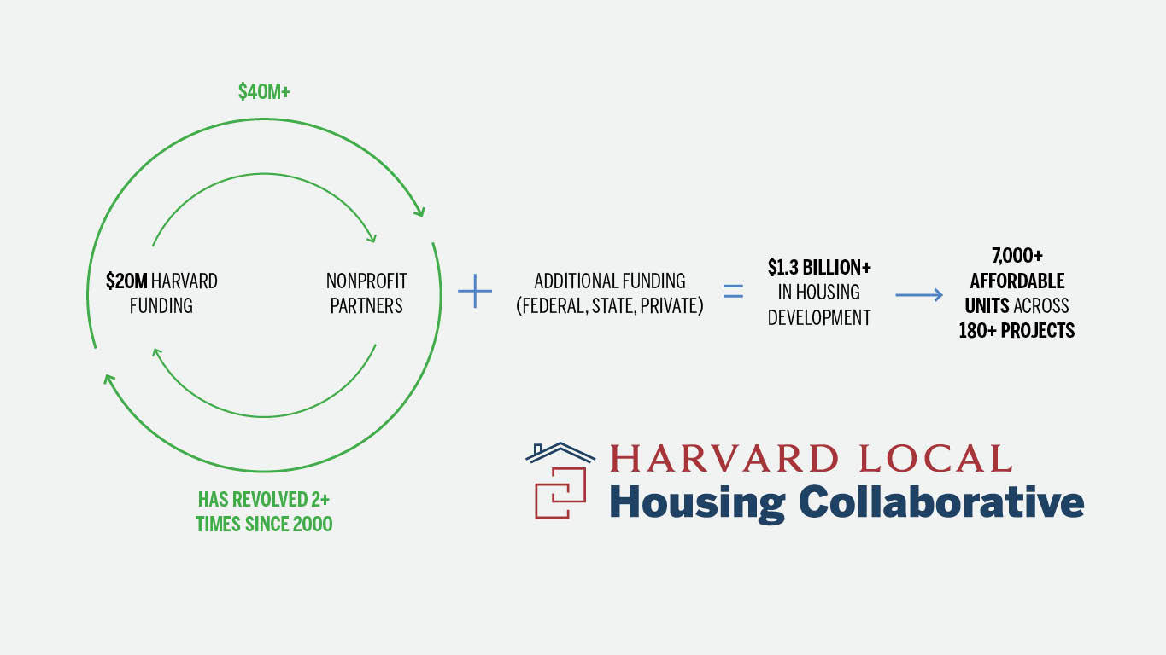

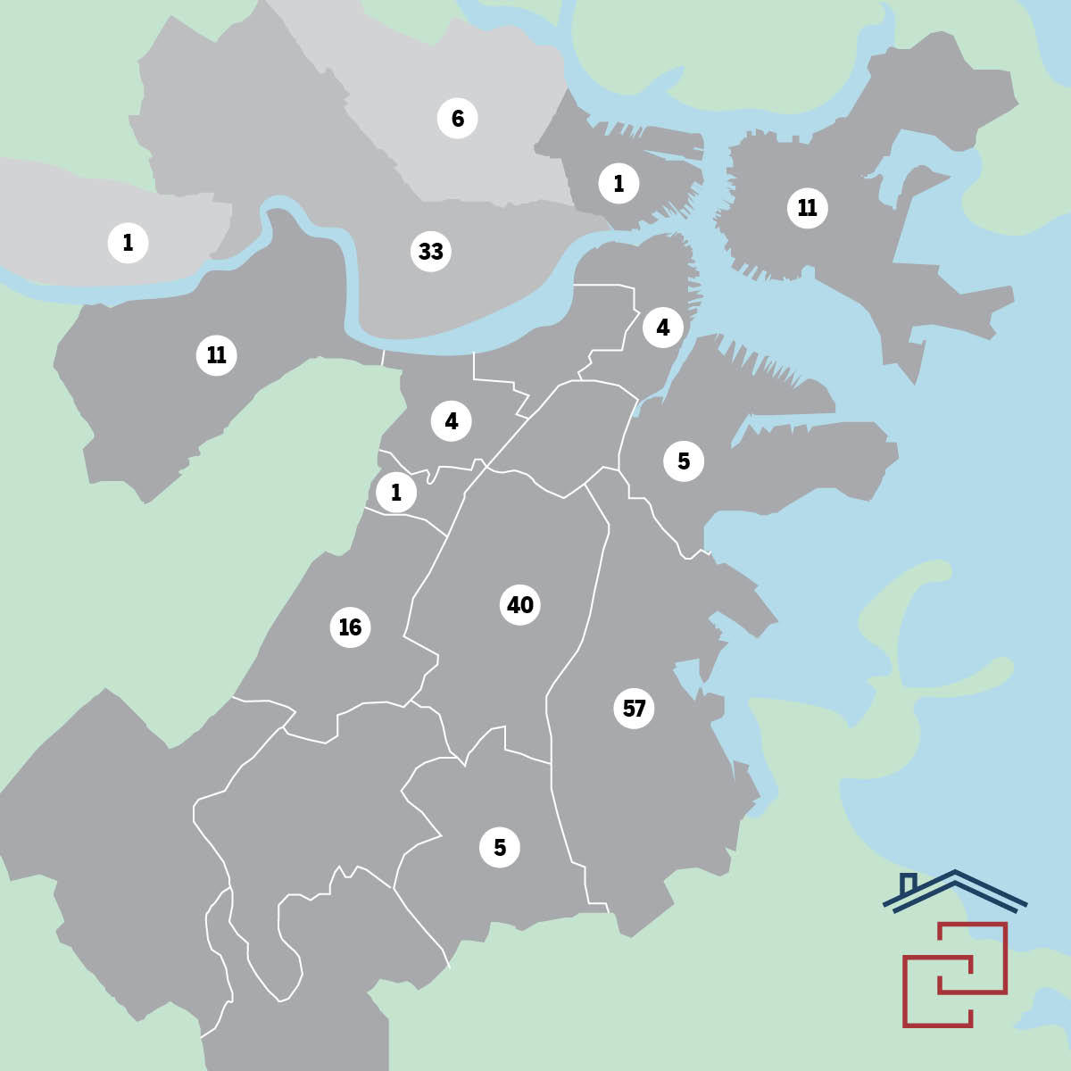
Example program from Cambridge, MA. Top: how the program combines institutional and public investments to create a gap funding program. Bottom: the projects that have created affordable housing in the Boston area as a result of the program.

Project goals and components
- Follow the model of the Harvard Local Housing Collaborative to create a shared institutional and public gap investment revolving loan program. The Cambridge example is a $20 million fund that has revolved more than twice since it was established in 2000, resulting in over $40 million in Harvard financing that leveraged $1.3 billion in housing development in 180+ projects in the Boston area.
- Creating such a program in Pittsburgh would achieve multiple benefits:
  - Create a new funding source for affordable housing that can meet the scale and regional geography of the housing crisis.
  - Creates partnership between the institutions and the City of Pittsburgh to manage the impacts of our region’s success and ensure housing remains available to everyone in near-in locations that support more equitable outcomes.
  - Funding could be targeted to areas adjacent to existing and proposed high frequency transit to reap the benefits of equitable transit oriented development and public investments in transportation.
- The likely investments could be lower than in the Cambridge model, unless multiple organizations are involved (e.g., University of Pittsburgh, UPMC, CMU, etc.).
- Further study is needed to identify the best roles for partners to play.

Project lead(s)
City of Pittsburgh and institutional partner

Project partner(s)
UPMC, University of Pittsburgh, CMU, HACP, URA, HACP, URA, Allegheny Conference, Allegheny County, and Foundation community.

