Traffic Calming Corridors and Strategies
Install traffic calming treatments on high-speed streets throughout Oakland at intersections and corridors that pose safety risks.

What we heard
- Oakland stakeholder input and traffic analysis revealed problems with fast traffic between intersections along several corridors.
- These include principal thoroughfares like Boulevard of the Allies and neighborhood streets like South Dithridge that are attractive shortcuts for through traffic.

When to start
When considering which locations to improve soonest, prioritize ones that meet the following criteria, defined by DOMI’s Neighborhood Traffic Calming Program (for more detail or to request a street be considered for traffic calming, go to Pittsburgh Neighborhood Traffic Calming | pittsburghpa.gov:
Eligibility prerequisites:
- Street owned by City
- Maximum two travel lanes if two-way street, or maximum one travel lane if one-way street
- Street classified as local street, collector, or minor arterial
- Roadway grade less than 13%
Prioritization – DOMI staff score requests based on these criteria as well as the DOMI Equity Index:
- Speed (85th percentile speed at least 5 mph above posted speed)
- Volume
- Crash history
- Pedestrian generators
- Presence of sidewalks
Where appropriate per the map and these criteria, incorporate traffic calming features on non-neighborhood streets. Boulevard of the Allies and portions of Bates that fall outside of the criteria above due to state ownership and/or width or slope differences warrant special analysis of traffic calming issues and potential solutions.
Corridor or area | Timeframe
Bates Street | 0-2 years
Boulevard of the Allies | 0-2 years
Robinson Street | 0-2 years
Central Oakland green streets | 3-5 years
Other improvements | ongoing

Duration
Several weeks to two years.

Estimated costs
$-$$ depending on facility design

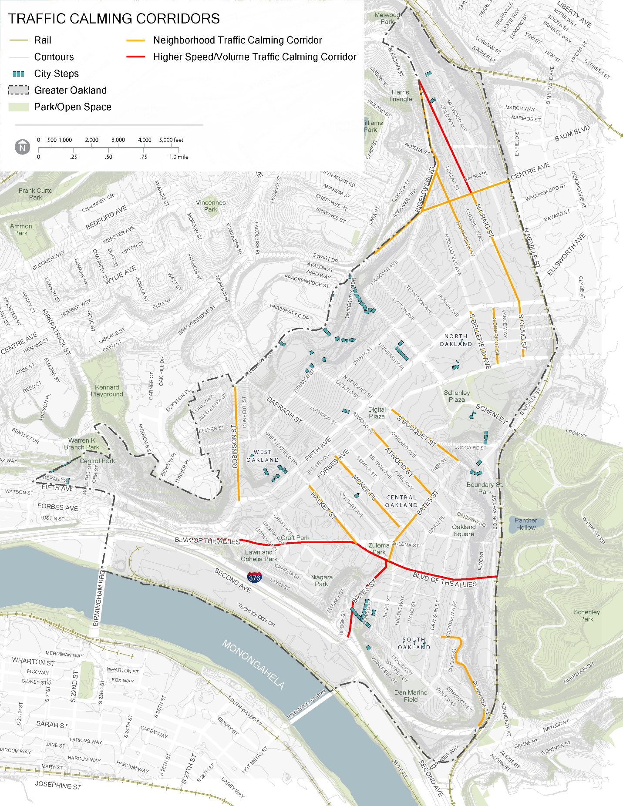

Traffic Calming Strategies
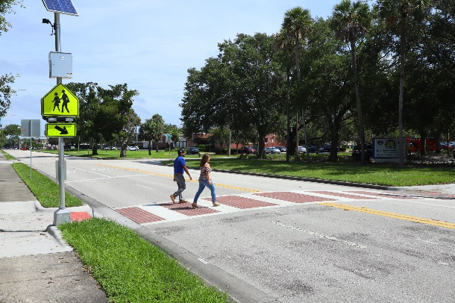
Midblock Crosswalks. Speeding typically occurs on longer blocks where regular intersections do not slow down drivers. Midblock crosswalks for pedestrians help slow vehicular traffic and enhance convenience and safety for pedestrians, who are then less likely to cross in uncontrolled locations between crosswalks in these areas. Common locations for midblock crosswalks include schools, parks, museums, transit stops, and other destinations. Image Source: Best Foot Forward
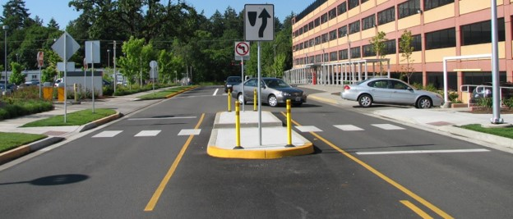
Pedestrian Refuge Islands. A crossing island in the median provides a protected area in the middle of a crosswalk for pedestrians to stop while crossing the street. Also called pedestrian refuge islands or median refuges, they can be used at intersections or mid-block crossings. Refuge islands may be incorporated into medians that are depressed, raised, or flush with the road surface. A median or island can also offer valuable opportunity for additional tree canopy, art object or other landmark, and/or stormwater bioswales. Image Source: NACTO
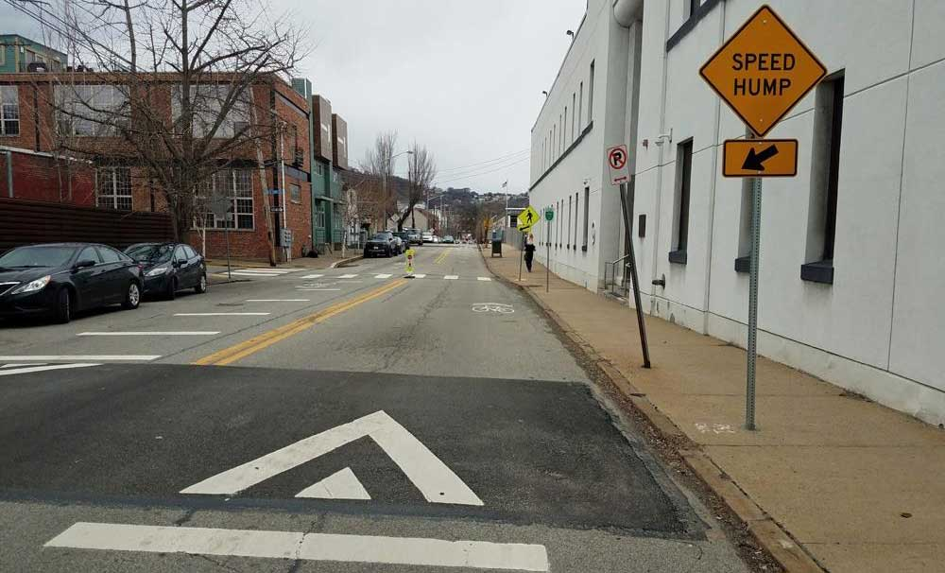
Speed Humps. A speed hump is a raised traffic-calming device located mid-block in the roadway to slow vehicular traffic and reduce speeds through vertical deflection. Typically, speed humps are 12 to 14 feet long and 3 to 4 inches high. The spacing of speed humps typically determines the speed at which motorists can drive. For example, spacing of approximately 250 to 500 feet tends to achieve an 85th percentile operating speed of between 25 and 30 mph. These are appropriate for neighborhood streets without bus routes where there is a need to slow through traffic. Image Source: DOMI
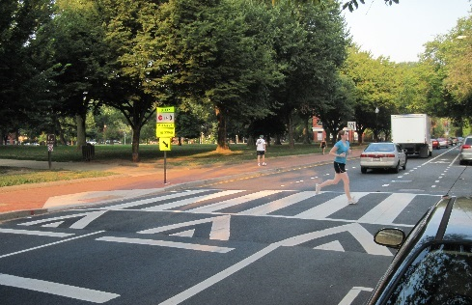
Raised Crosswalks. Raised pedestrian crosswalks bring the level of the roadway even with the sidewalk, providing a level pedestrian path and requiring vehicles to slow. Raised crosswalks can be used at mid-block crosswalks or intersections. Image Source: www.pedbikeimages.org / Dan Burden

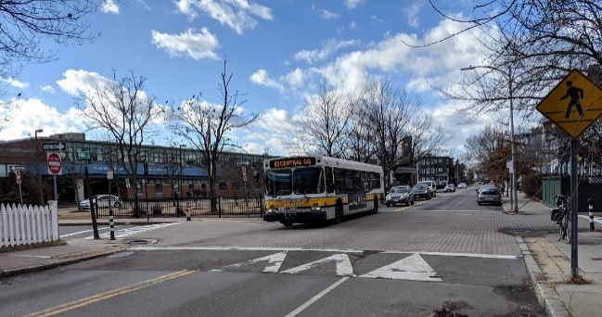
Raised Intersections. A raised intersection is a vertical treatment that raises the entire intersection above the surrounding roadway level. Also called speed tables, they require ramps on each intersection approach to elevate the entire intersection to the sidewalk level (3 to 6 inches above street grade) and use brick or other textured materials. Raised intersections reduce vehicular speeds and provide additional safety to pedestrians, particularly those with limited mobility. Image Source: Kittelson & Associates
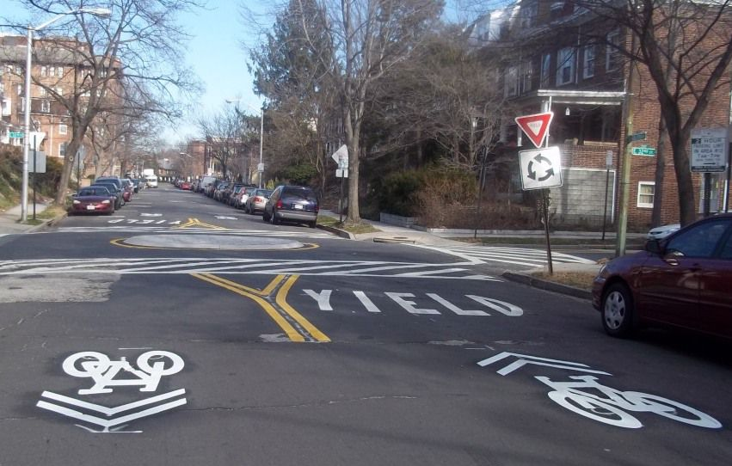
Mini Traffic Circles. Mini Roundabouts and neighborhood traffic circles lower speeds at minor intersection crossings and can be used at uncontrolled intersections. They can be installed using mountable curbs, raised curbs with landscaping, or using paint/delineator posts for quick-build projects. They are typically used on bicycle boulevards to ensure traffic speeds are slow enough for bicyclists to share the road with vehicular traffic. Image Source: NACTO
Project goals and components
Apply DOMI’s established Neighborhood Traffic Calming Program to efficiently remedy excessive traffic speeds on neighborhood streets in Oakland. Consider streets identified in the map above, as well as others for which neighborhood stakeholders submit requests. Apply specialized criteria and treatments as appropriate to streets like Boulevard of the Allies and portions of Bates that fall outside the criteria and purview of the established program. Improve pedestrian comfort and safety. See also the Pedestrian Safety Improvements strategy sheet, as some of its priority locations and strategies also address traffic calming priorities. Where recommended traffic calming corridors overlap street areas where pedestrian, bike, and/or other improvements are recommended, integrate design and implementation of traffic calming treatments with the other initiatives.

Project lead(s)
DOMI

Project partner(s)
PennDOT, OTMA, OPDC, neighborhood associations according to location

