Pedestrian Safety Improvements
Install pedestrian safety improvements throughout Oakland at intersections and corridors that were identified during the planning process as posing safety risks.

What we heard
- In 2018, 34 vehicle-pedestrian crashes occurred in Oakland
- In addition to locations with high crashes, Community members identified intersections and corridors that pose safety risks, including Boulevard of the Allies, Bates Street, Fifth/Forbes Avenue, and Centre Avenue

When to start
When considering which locations to improve soonest, prioritize ones that meet at least two or more of the following criteria:
- Corridor or area with timeframe of 0-2 years or ongoing (see table below)
- Consistency of vehicle-pedestrian crashes year after year, especially crashes with injuries or fatalities
- Consistently high pedestrian volume
- Adjacency to bus stops and bikeshare stations
- Potential implementation within 6-12 months
- Implementation costs low enough that resources can extend to cover improvements at additional locations
Corridor or area | Timeframe
Bates Street | 0-2 years
Boulevard of the Allies | 0-2 years
Robinson Street | 0-2 years
Central Oakland green streets | 3-5 years
Other improvements | ongoing

Duration
Many improvements can be designed and implemented in a matter of days or weeks unless part of a larger multi-modal improvement project, which may take up to two years.

Estimated costs
$-$$ depending on facility design

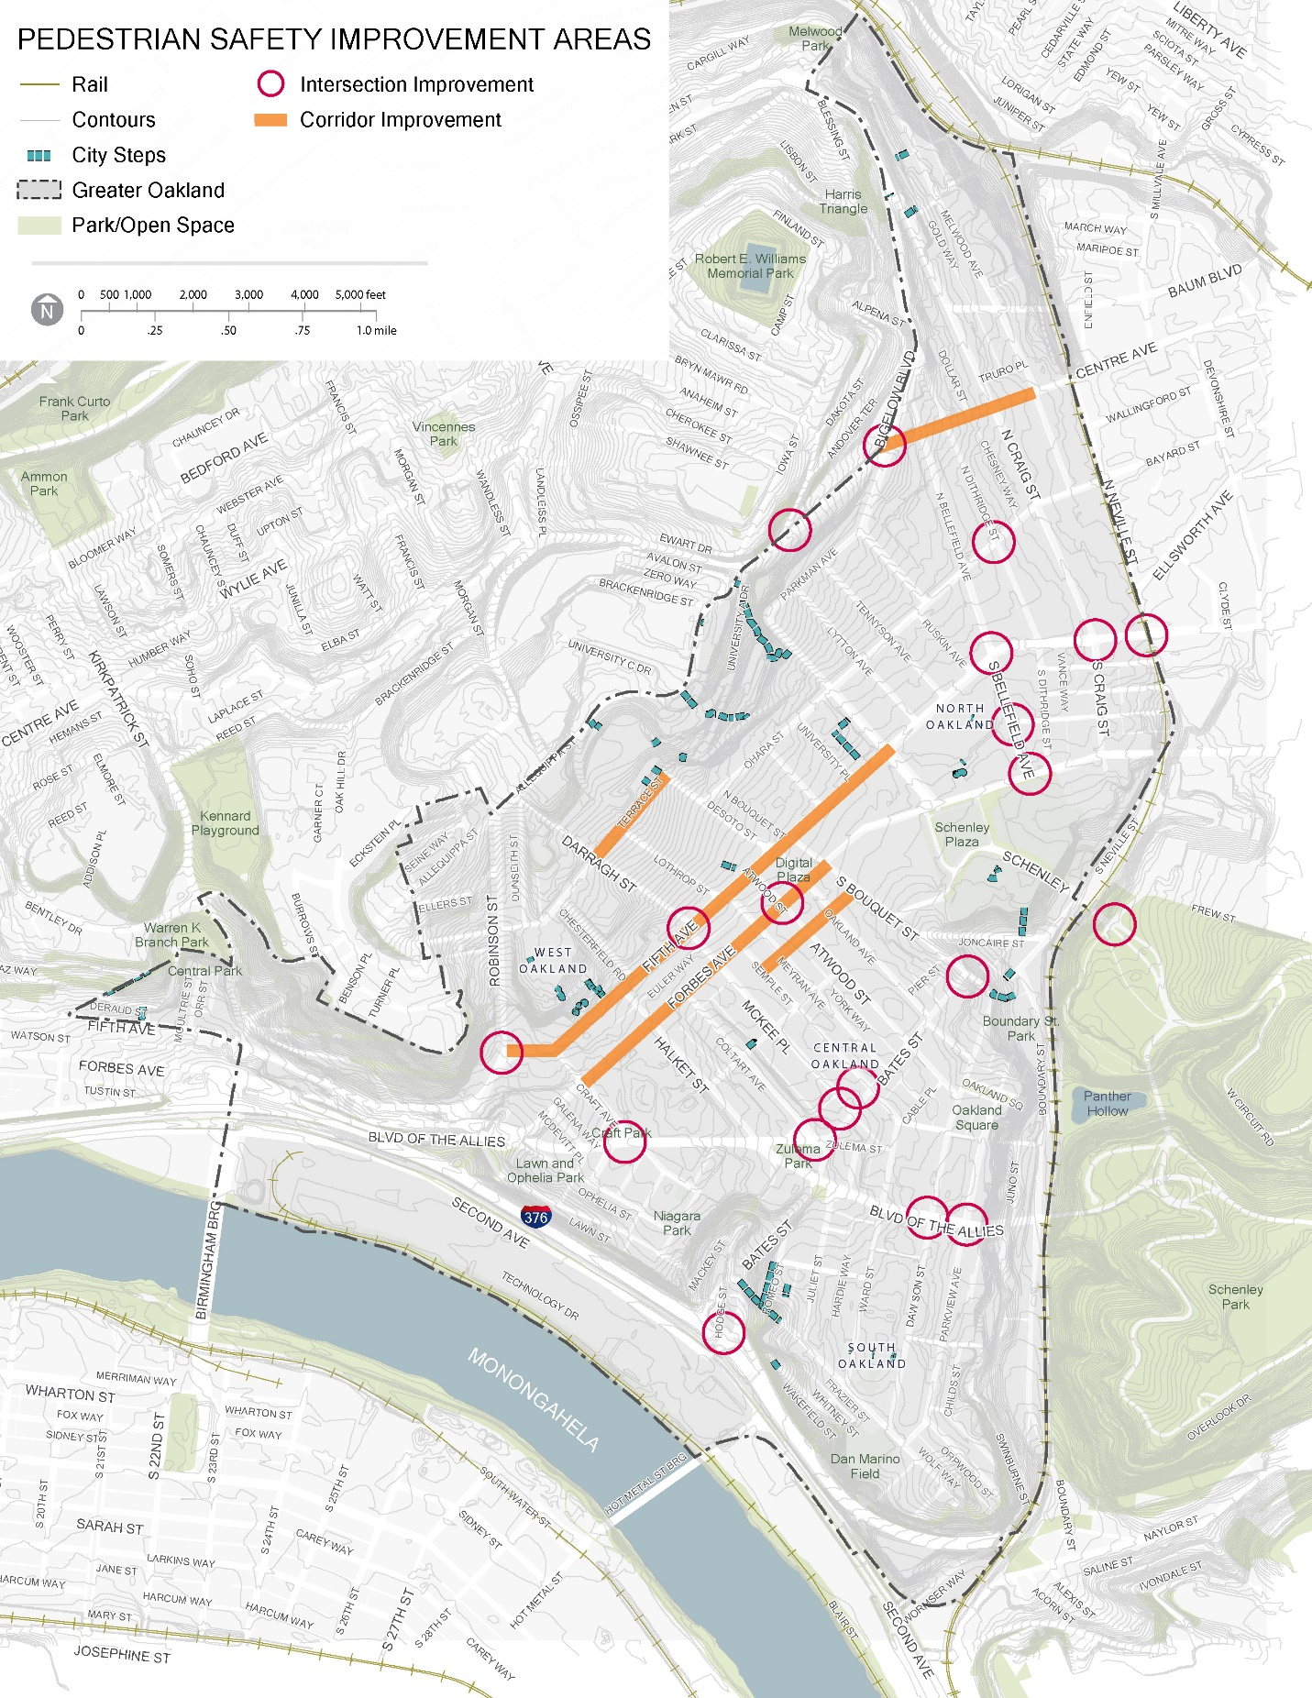

Pedestrian Safety Improvements Toolkit
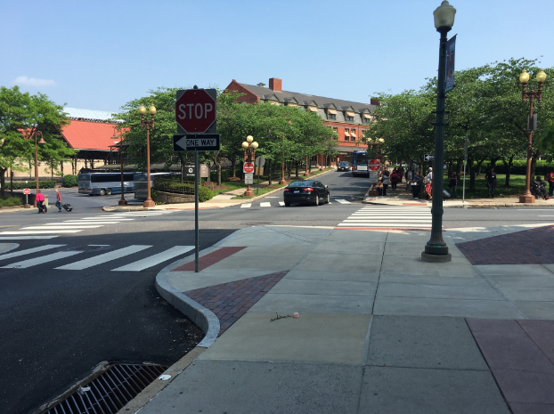
Bump-outs and other reductions in crosswalk length. Extending the sidewalk zone across a parking lane or other paved area not used for vehicle travel reduces pedestrian exposure to traffic, improves visibility of pedestrians and vehicles to each other, expands pedestrian waiting space, and helps calm traffic speed. It can also create opportunities for adjacent streetscape plantings and/or stormwater bioswales. Where crosswalks traverse a street at a sharp angle, consider opportunity to realign the crosswalk to be more perpendicular to the intersecting street, thus reducing its length. Image Source: PennDOT

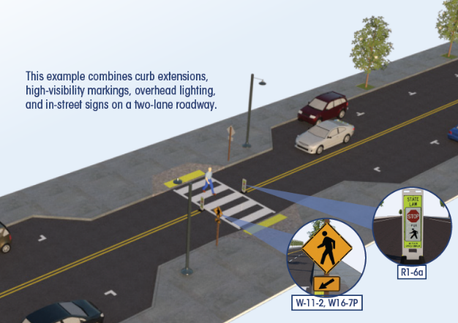
Crosswalk visibility enhancements (high visibility crosswalks, improved lighting, and enhanced signing and pavement markings). These FHWA proven safety countermeasures help drivers anticipate and see pedestrians, and give pedestrians greater confidence using the sidewalk network. Image Source: FHWA

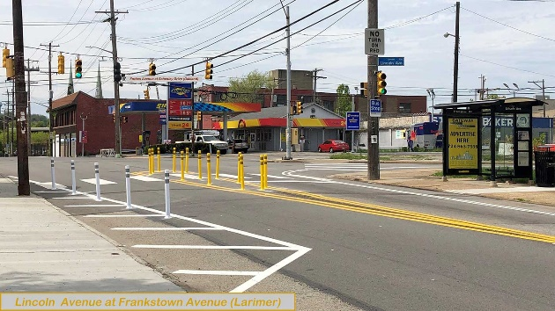
Intersection Daylighting. Improve visibility of pedestrians at intersections by removing parking or other visual obstructions within 20-25 feet of the intersection. Daylighting areas should be defined both through pavement markings and vertical elements (e.g. flexible delineator posts). If sidewalk bump-outs are not installed, flex posts at either side of the vehicle travel lanes are important to keep vehicles out of pedestrian areas. Paint can also be used to highlight pedestrian areas extending beyond the curb. Image Source: DOMI
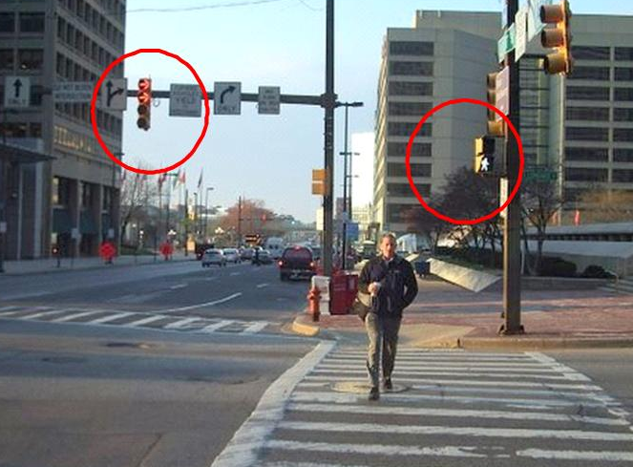
Leading Pedestrian Interval (LPI). A leading pedestrian interval gives pedestrians at a signalized intersection a 3-7 second head start before the concurrent vehicle phase turns green. This allows pedestrians to enter and occupy the crosswalk before the turning vehicles.

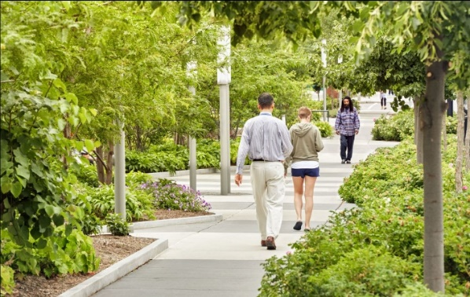
Wider Sidewalks. Street trees, a planting strip or verge, and parallel parking all increase pedestrian comfort by placing physical barriers between pedestrians and vehicle traffic. While many Oakland sidewalks are constrained in width by buildings, narrow sidewalks with significant pedestrian volumes should be widened onto property easements or within the right of way where possible. Image source: Scape Studio

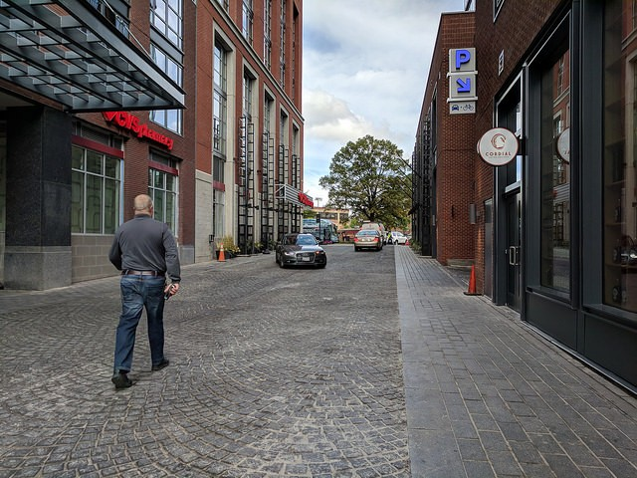
Shared Pedestrian/Vehicular Street. Where vehicle traffic is light, creating a shared street turns a narrow street with one or two inadequate sidewalks into a welcoming walk. It also makes the street more suitable to host periodic and popup events, expanding limited public gathering space. Image source: Payton Chung/Greater Greater Washington

Project goals and components
Reduce incidence of vehicle-pedestrian and bike-pedestrian crashes, while increasing pedestrian volumes. Improve pedestrian comfort and convenience. Coordinate improvements with accompanying improvements to bus stops, bike facilities, tree canopy, stormwater management, and/or other transportation and streetscape initiatives where present. Coordinate with informational campaign on health benefits of walking.

See also the Traffic Calming Corridors and Strategies sheet, as some of its priority locations and strategies also address pedestrian safety priorities.

Project lead(s)
DOMI

Project partner(s)
Institutions, OTMA, OBID, OPDC, other neighborhood organizations according to location, PennDOT, SPC, DPC, Oakland for All

