Bike Route Improvements
Fill critical gaps in Oakland’s bicycle network through the installation of safe, convenient bicycle facilities that would make biking a reasonable transportation option for thousands more people.

What we heard
- Many people travel by bicycle in Oakland daily, some utilizing its 18 Healthy Ride bikeshare stations
- Dedicated bicycle facilities in Oakland are separated by challenging gaps, requiring cyclists to use portions of cautionary bike routes on Forbes, Fifth, Bates, and Boulevard of the Allies to reach their destinations
- Better connections are needed to existing trails in Panther Hollow and the Eliza Furness Trail

When to start
Implementation timeframes for the recommended bicycle corridors are shown below. The corridors should also be prioritized based on ability to meet criteria discussed under Project Goals and Components below.

Corridor or area | Timeframe
Bates Street bike facilities | 0-2 years (2nd Avenue to Boulevard of the Allies)  5-7 years (Boulevard of the Allies to McKee Place)
Boulevard of the Allies bike facilities (east of Bates) | 0-2 years
Robinson Street | 0-2 years
Fifth Avenue bikeway extension – South Bellefield to Neville Streets | 3-5 years
McKee Place | 3-5 years
Other improvements | ongoing

Duration
Individual infrastructure components may take up to two years for design and construction.

Estimated costs
$-$$ depending on facility design

Illustration(s)
The map on the next page indicates proposed bike facilities in context with existing ones. These proposed facilities reflect a synthesis of recommendations from Oakland community members, BikePGH, City of Pittsburgh, and the consultant team.

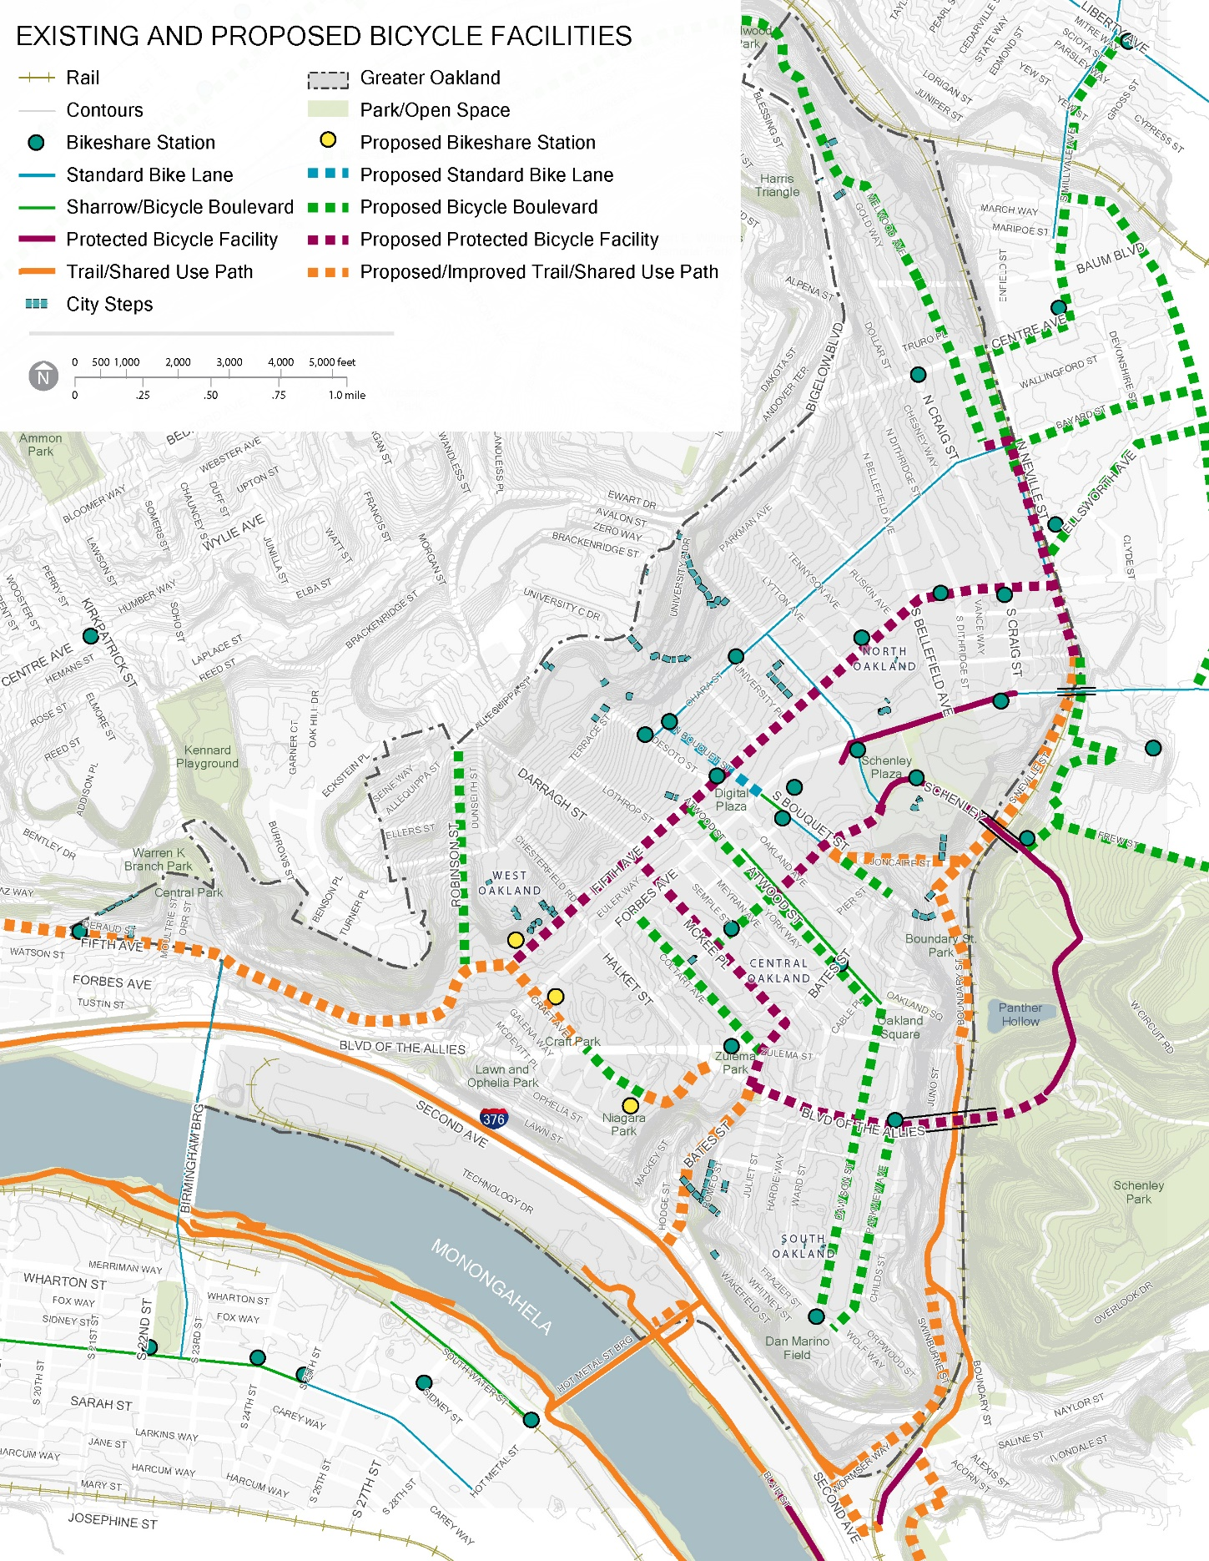

Proposed Bicycle Facility Types:
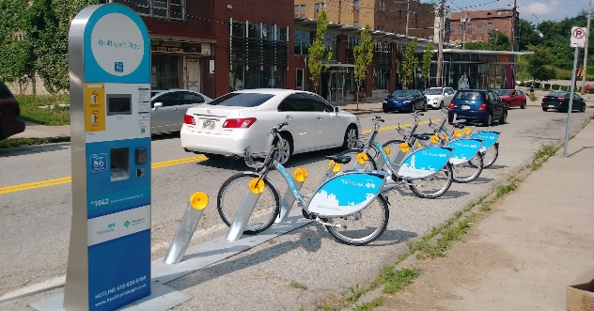
Healthy Ride Bikeshare Stations. Three suggested locations expand on the 18 existing Healthy Ride stations, with a focus on the convergence of West and South Oakland where major existing UPMC and Carlow University campuses and neighborhood areas lack nearby bike stations. Image source: Healthy Ride

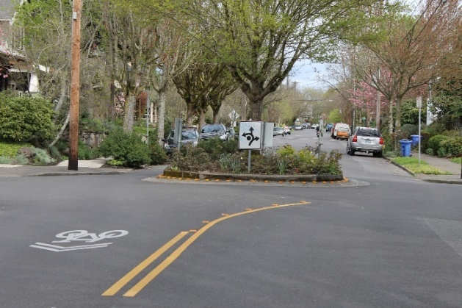
Bicycle Boulevard. Bicycle Boulevards are relatively inexpensive, quick to install, inviting to cyclists, and can be appropriate along neighborhood streets with low vehicular volumes and speeds and insufficient space for dedicated bike lanes. Bikes and vehicles share a common travel lane, with lane markings, signage, and speed humps or chicanes that advise drivers to expect cyclists and keep speeds low. Recommended locations include Robinson Street, Atwood Street, Dawson Street, and Parkview Avenue, which together would provide valuable bike network connections between the Forbes/Fifth corridor, West Oakland, Central Oakland, South Oakland, and Schenley Park. Image source: Madison Bike Life: Portland's Bicycle Boulevards, Where Bikes Take the Lane

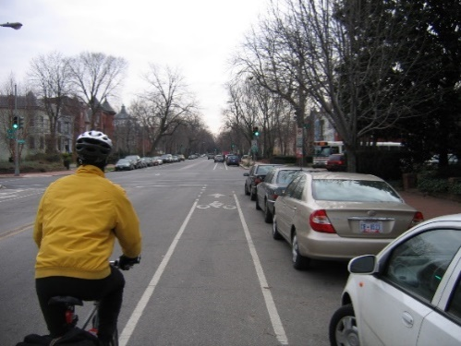
Standard Bike Lane. A standard bike lane is relatively inexpensive and quick to install, and can be appropriate along streets with slow, moderate vehicle traffic. Image source: Kittelson & Associates

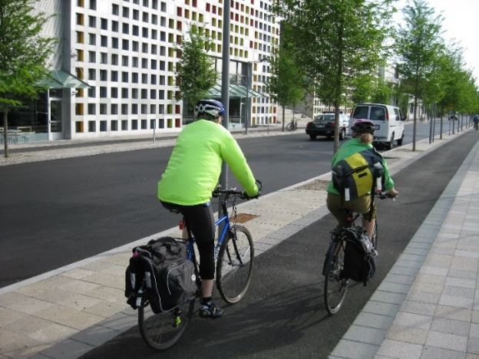
Protected Bicycle Facility. This is a bike lane that is separated from vehicle lanes by parked cars, bollards, curbing, or other physical barrier for enhanced safety and cyclist comfort. This level of investment is a high priority where it makes useful network connections that enable cyclists to avoid high-traffic streets. The map shows the planned two-way cycle track along Fifth Avenue as part of the proposed BRT improvements and proposed facilities on other streets including McKee Place and Neville Street. Image source: CHPlanning.
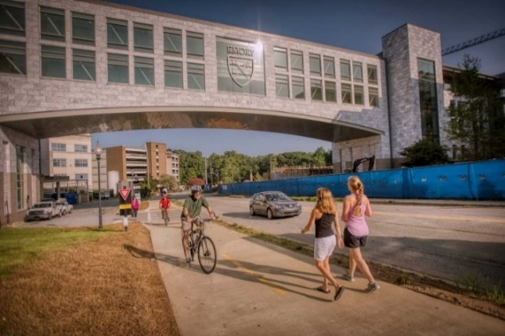
Trail or Shared Use Path. This facility combines bike and pedestrian passage, and preferably includes a center line to organize directional movement. It is generally appropriate where there is insufficient room for parallel bike facilities and sidewalks, and where adjacent buildings and driveways are infrequent enough that pedestrian and cyclist movements are unlikely to conflict. The proposed shared use paths generally occur at Oakland’s perimeter and connect with adjoining neighborhoods and regional greenways, through areas with steeper grades and less development. Image source: Emory University

Project goals and components
Each new bike facility segment should extend far enough to close a significant network gap or reach a significant cycling destination. New segments should avoid endpoints that force cyclists to use cautionary bike routes. Because many facilities require reconfiguration of the street section and/or some additional right of way, it will be important to coordinate them with other street improvements (addressing elements like pedestrian safety, street trees, and parking) and engage major adjoining property owners and district organizations as partners where appropriate.

The following three corridors identified on the proposed bicycle network are key connections that should be prioritized for implementation over the next 10 years. These corridors, when combined with the two-way cycle track to be constructed on 5th Avenue, will create continuous connections via protected bicycle facilities between Schenley Park, the Eliza Furness Trail, and south and central Oakland.
- Bates Street from Eliza Furness Trail to McKee Place
  - PennDOT’s design project is underway for Bates Street south of Boulevard of the Allies to widen the street and incorporate bicycle facilities. A sidewalk-level or protected two-way facility with a new direct connection to the Eliza Furness Trail is preferred for this segment.
  - The two-way protected bicycle facility on Bates Street should be extended north of Boulevard of the Allies to connect to the proposed two-way cycle track on McKee Place. This can be combined with future redevelopment around Zulema Street.
- McKee Place from Bates Street to 5th Avenue - A two-way protected bicycle facility will connect the proposed protected bicycle facility on Bates Street with the future cycle track on 5th Avenue in Central Oakland.
- Boulevard of the Allies from Schenley Park to Bates Street – A two-way protected bicycle facility will provide connections between Schenley Park and the proposed protected bicycle facilities on Bates Street and McKee Place.

Project lead(s)
DOMI

Project partner(s)
Institutions, OTMA, OPDC, OBID, BikePGH

