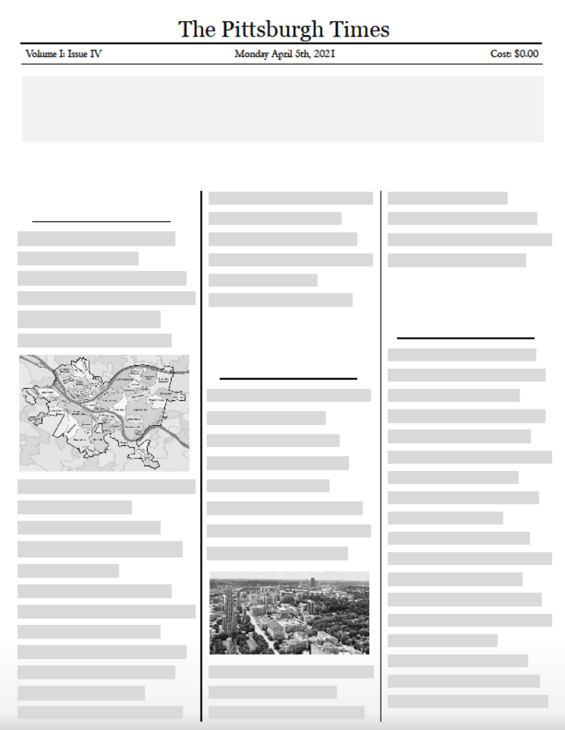
This is the second of three major issues for the above challenge.

This is the third of three major issues for the above challenge.

Add more notes about this first issue by clicking here.
This is the first of three major issues for the above challenge.

CLICK HERE TO WRITE YOUR HEADLINE:
Public Safety and Public Health in Oakland face this major challenge TODAY.

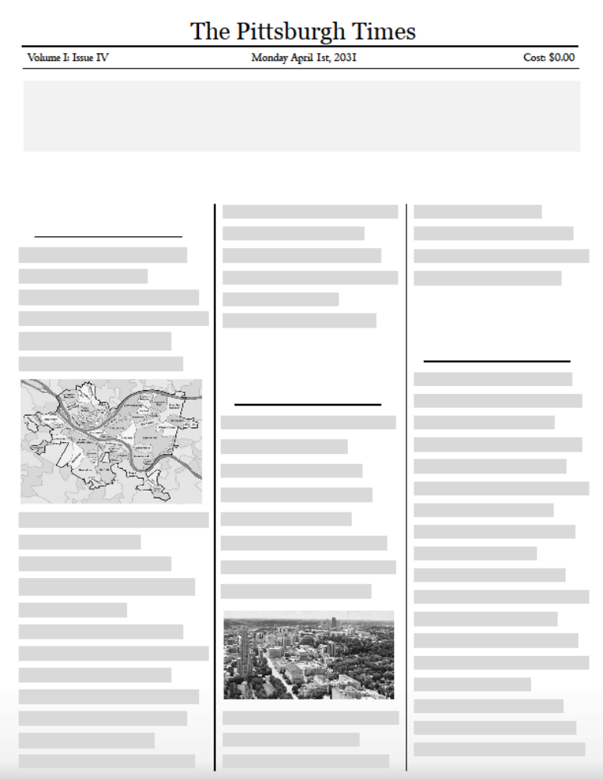
This is the third of three initiatives that achieved the above accomplishment.

This is the second of three initiatives that achieved the above accomplishment.

Add more notes about this first initiative by clicking here.

This is the first of three initiatives that achieved the above accomplishment.

CLICK HERE TO WRITE YOUR HEADLINE:
Oakland is known for this public safety and public health accomplishment IN 10 YEARS.

