Bus Stop Enhancements

What we heard
There is a need to improve bus stop amenities to improve the comfort and overall experience of taking transit in Oakland. There is a desire for more bus shelters in Oakland. Residents have also requested trash cans at select bus stops and clear signage when bus stop locations change.

When to start
0-2 years

Duration
Ongoing

Estimated costs
$$ - Cost will vary depending on the type of improvements for each individual bus stop. This estimation takes into account the average cost for the selected group of bus stops that will be upgraded.

Illustration(s)

Current Bus Stops in Oakland

Figure 1 shows the existing bus stop types in Oakland based on average daily boardings. According to the Port Authority of Allegheny County (PAAC) Bus Stop and Street Design Guidelines, the appropriate amenities for bus stops are determined by bus stop type, and bus stop type is primarily determined by ridership. Each bus stop will need to be evaluated by PAAC to determine the correct bus stop type. Figure 2 shows the criteria from PAAC on bus stop type based on daily boardings.

Figure 1. Bus Stop Type Based on Average Daily Boardings
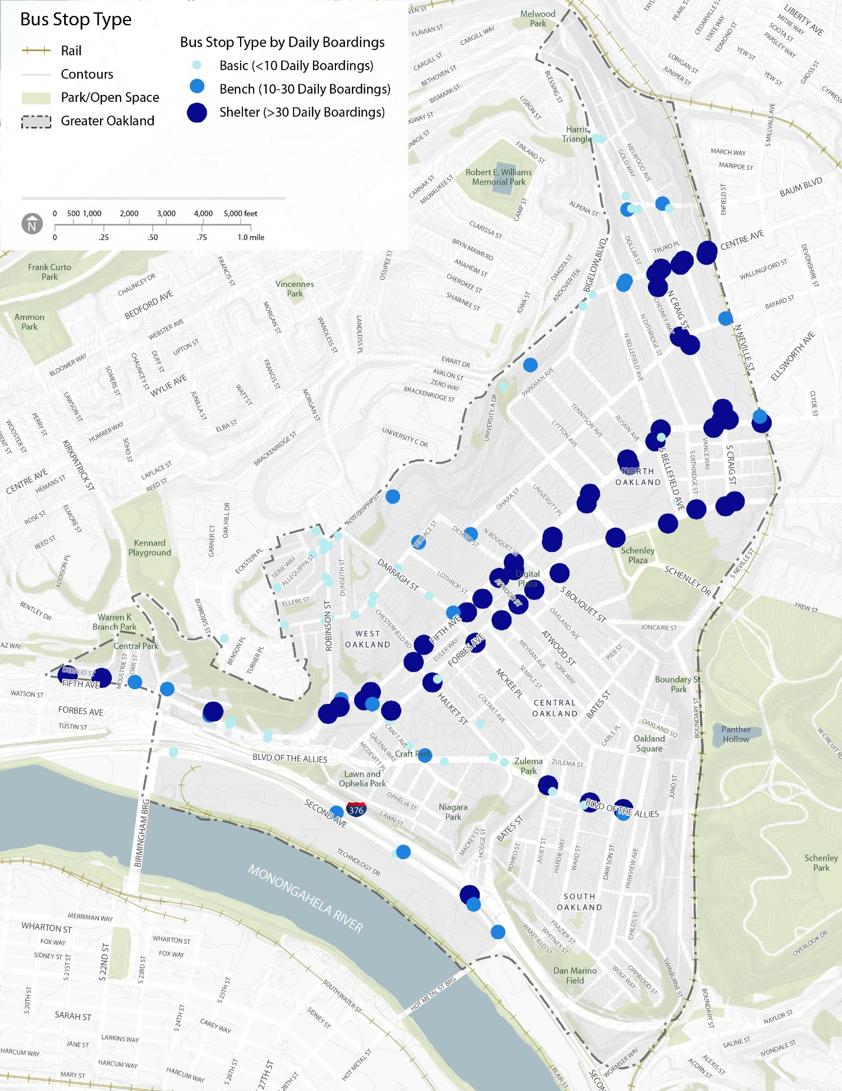

Figure 2. Bus Stop Type by Boardings (Source: PAAC Bus Stop and Street Design Guidelines)
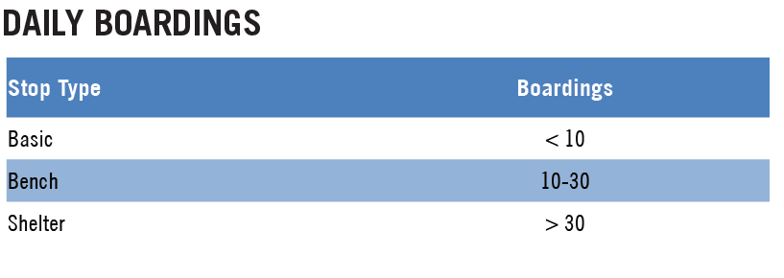
Figure 3 shows the amenity matrix by bus stop type. There are four main groups of amenities, bus stop infrastructure, placemaking, multi-modal connections, and transit operation enhancements. The matrix provides a description of each amenity type and at which bus stop types that amenity is most appropriate. This matrix is meant to serve as a starting point of reference for determining which amenities to propose. Each bus stop should be evaluated on a case-by-case basis to determine the most appropriate amenities.

Figure 3. Amenity Matrix
Amenity Type | Amenity | Description | Priority | Bus Stop Type
 |  |  |  | Basic | Bench | Shelter
Bus Stop Infrastructure | Sign, Pad, and Sidewalk | All bus stops should have a sign identifying the stop, an ADA accessible loading zone for boarding and leaving bus, and connection to sidewalk | High
Bus Stop Infrastructure | Bench and trash can | Bench for riders to sit while waiting for the next bus; Trash can to discourage littering near stop | High
Bus Stop Infrastructure | Bus shelter and pedestrian scale lighting | Bus shelter to protect riders from inclement weather; Lighting to increase pedestrian visibility | High
Bus Stop Infrastructure | Wayfinding | System map and route schedule; Real-time arrival information | Medium
Bus Stop Infrastructure | Ticket Vending | Kiosk at station for rider to purchase tickets | Medium
Safety/Accessibility | Sidewalk | Continuous sidewalks in good condition with adequate clear zones connecting the bus stop to the nearest crossing opportunities | High
Safety/Accessibility | Crosswalks | High visibility crosswalks with accessible curb ramps at nearest crossing opportunities | High
Safety/Accessibility | Enhanced crossing treatments | Where marked crosswalks are insufficient to assure pedestrian safety, consider combinations of the following types of safety treatments: median islands, curb extensions, reduced curb radii, pedestrian warning signs, pedestrian signals | High
Multimodal Connections | Curbside bike lane | Bike lane is curbside. Bus enters bike lane when at stop. This may force the bicyclist to enter the travel lane or ride on the sidewalk. Only appropriate when there is less than 10 feet of available right-of-way. | Medium
Multimodal Connections | Raised Cycle Lane (Shared) | Bike lane is raised to sidewalk grade and shares space with pedestrians in front of bus stop. A 5 foot minimum clear path and 8 foot long landing pad must be provided in the shared space. Requires 10 to 13 feet of right-of-way. | Medium
Multimodal Connections | Raised Cycle Lane (Separate) | Bike lane is raised to sidewalk grade but there is clearly delineated space for bikes and for pedestrians. Requires 13 to 21 feet of right-of-way | Medium
Multimodal Connections | Boarding Island | Route the bike lane behind the bus stop, creating a boarding island which eliminates the conflicts between bicycles and riders. Requires more than 21 feet of right-of-way | High
Multimodal Connections | Bike Parking | Dedicated space to park bikes | High
Multimodal Connections | Bike Share Station | Nearby bike share station provides bikes to help riders reach final destination | Medium
Transit Operation Enhancements | Bus Lanes | Dedicated lane for buses to reduce delay caused by traffic congestion. Only install on corridors with frequent bus service and consistent traffic congestion | Low
Transit Operation Enhancements | Bus Stop Cross Hatching | Mark bus stop area with white cross-hatching to clearly indicate the bus stop location and discourage illegal parking in bus stop zone. Appropriate in areas with consistent parking regulation compliance issues | Medium
Transit Operation Enhancements | Bus Stop Lengthening | Stops that serve multiple routes may need to be extended to allow for at least two buses at the stop at the same time. The appropriate bus stop length is determined if the stop is near-side, far-side, or mid-block, and the size of the bus that uses that stop | Medium
Placemaking | Public Art | Murals, Posters, Sculptures, Plaques, and other artforms to improve aesthetic quality of stops and promote community identity | Medium

- Highly Desired
- Recommended
- Generally not recommended

Project goals and components
- Project Description
  - For transit riders, the quality of bus stops play an important role in the comfort and overall experience of taking transit.
  - Enhancing bus stops will improve access, comfort and mobility of transit riders.
  - Each year a group of bus stops will be selected for improvements. Using the bus stop amenity matrix, specific investments will be made based on stop type, ridership, location, and other characteristics
  - The group of stops selected will be based on a prioritization tool along with stakeholder input
- Project Goals
  - Ensure all bus stops have minimum amenities for the stop type as described in the Port Authority of Allegheny County (PAAC) Bus Stop and Street Design Guidelines
    - Basic Bus Stop Requirements – sign, ADA accessible loading pad, and connection to the sidewalk
    - Bench Bus Stop Requirements – All that is included for basic stops plus a bench and a trash can
    - Shelter Bus Stop Requirements – All that is included for bench stops plus a shelter and lighting
  - Where appropriate based on the amenity matrix, install additional amenities to bus stops to further enhance accessibility, comfort, and multi-modal connections
  - Invest in bus stop enhancements in an equitable way that ensures investments are made in all communities in Oakland
  - Use bus stops as placemaking tools by including public art made by Oakland residents and including Oakland residents in the design and decision-making process
- Prioritization Tool
  - Not all bus stops can receive enhancements at the same time. Therefore, it is important to develop a framework that will prioritize the critical bus stops to invest in first.
  - It is assumed Bus stops on Fifth Avenue and Forbes Avenue will be upgraded with the ongoing bus rapid transit (BRT) project.
  - Key Factors for Prioritization
    - Current status of bus stop – Does the bus stop already have the standard amenities based on the bus stop type?
    - Density – How many people live near the bus stop?
    - Land use and development – How many jobs and major activity centers are near the bus stop?
    - Vulnerable populations – Is there a higher share of seniors, people with disabilities, children, or low-income households living near the bus stop?
    - Transit connections – Does this stop serve multiple PAAC routes or connect to paratransit, campus shuttles, regional transit, or other transit services?
    - Multimodal connections – Does this stop connect to existing or planned bicycle or pedestrian infrastructure (e.g. bike lanes, bike share stations, sidewalks, trails, etc.)
    - Alignment with other planned projects – Is the bus stop on a road with a planned project and/or resurfacing?

Project lead(s)
The Port Authority of Allegheny County (PAAC) and DOMI will both co-lead this project.

Project partner(s)
The Arts and Design Committee, the Oakland Planning and Development Corporation (OPDC), and Neighborhood Associations will support PAAC on this project.

Research

PAAC Bus Stop Guidelines

- Bus Stop Goals
  - Safe
  - Secure
  - Accessible
  - Detectable
  - Identifiable
  - Efficient
  - Maintained
  - Coordinated
- Bus Stop Placement
  - Near-side
  - Far-side
  - Mid-block
  - 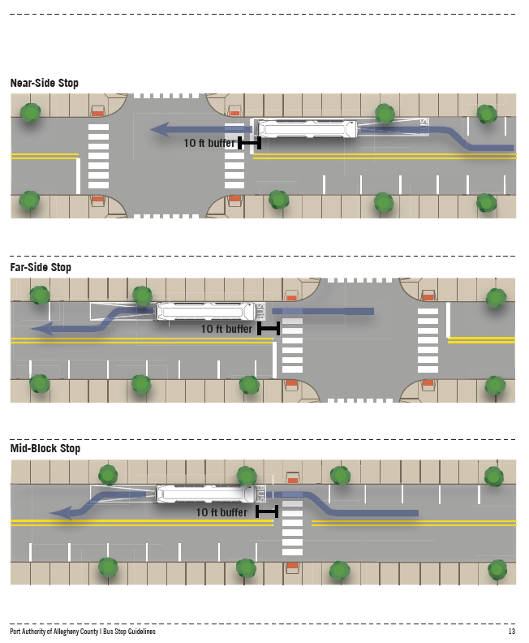
- Bus Stop Spacing
  - 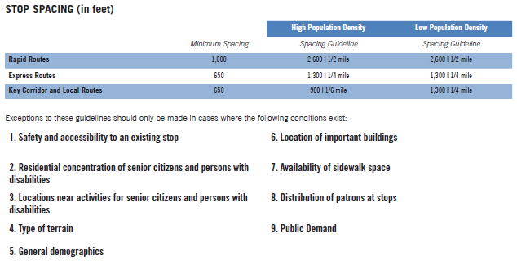
- Curbside Design
  - 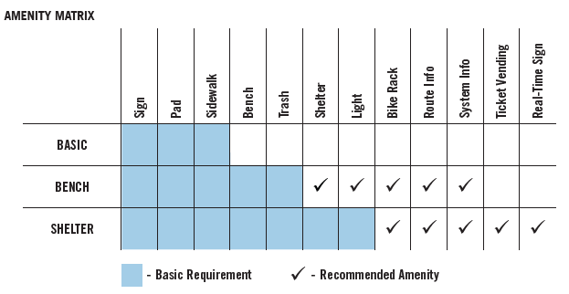
  - Four types: Basic, bench, shelter, and station
  - 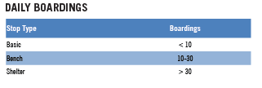
  - 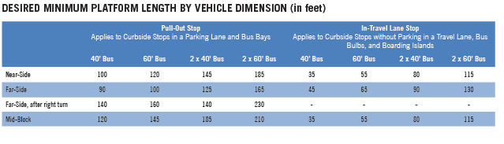
  - 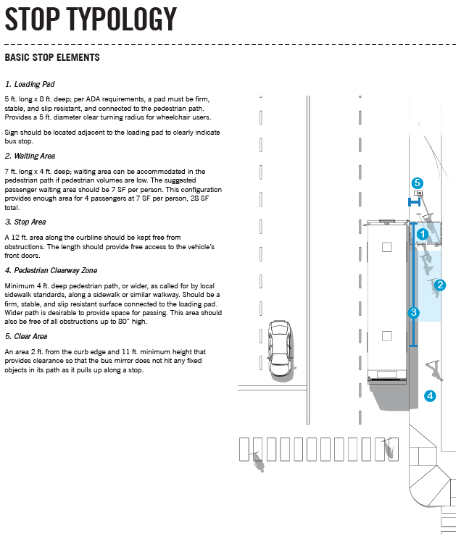
  - 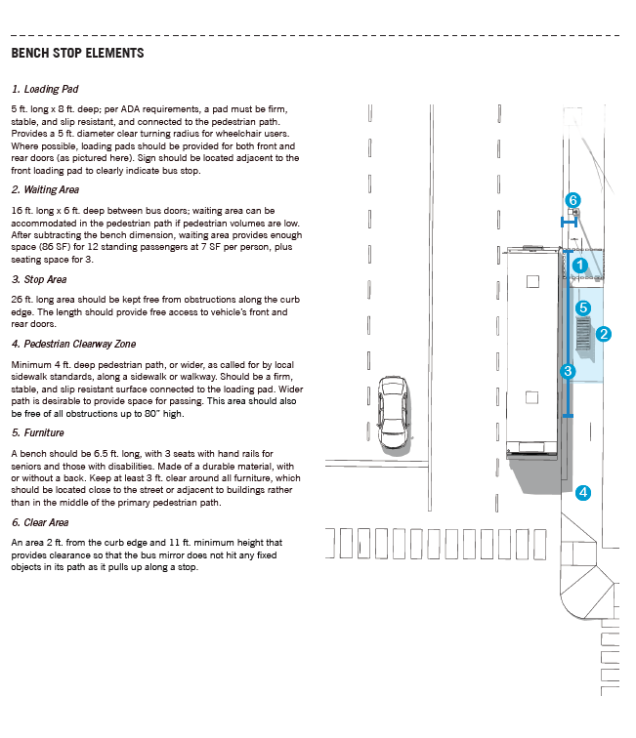
  - 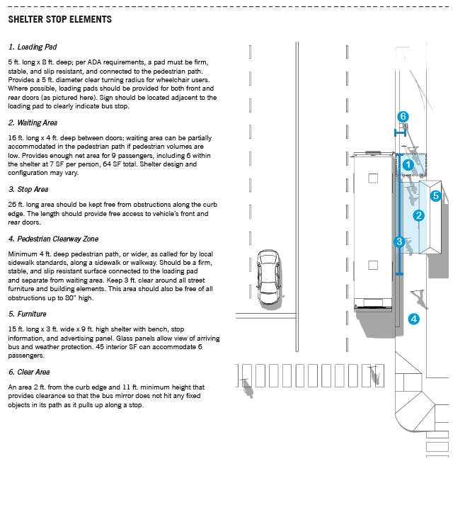
- Bike lane considerations
  - 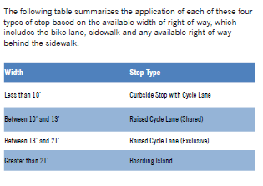
  - 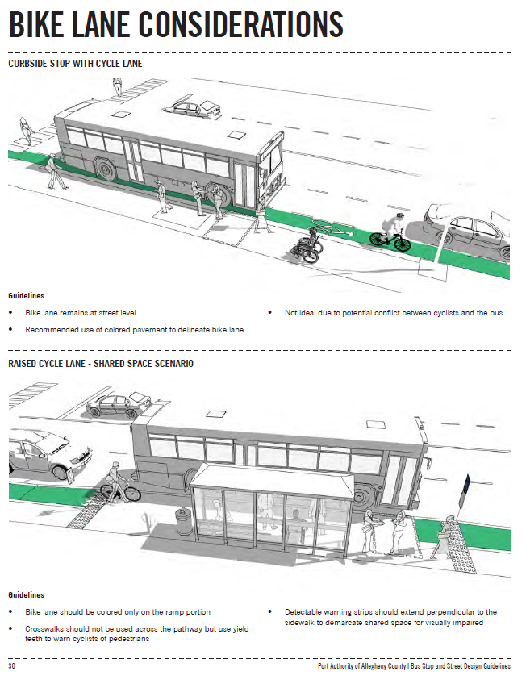
  - 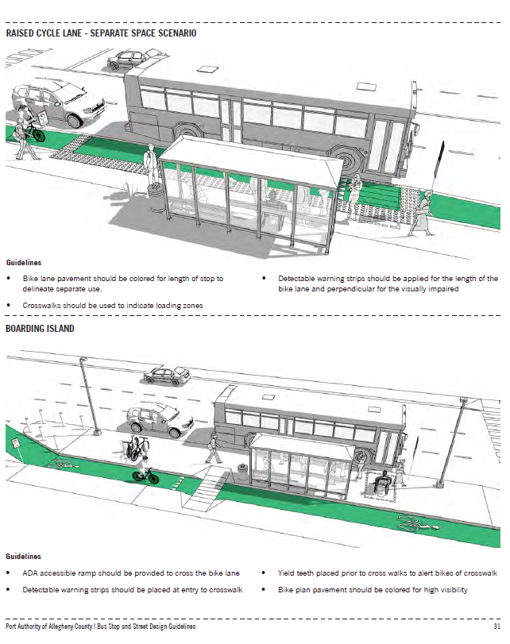
- Bus Stop Amenities
  - Amenity criteria
    - Density
    - Land use and development (employment centers, mixed use developments, other major activity centers)
    - Population considerations (seniors, people with disabilities, youths, low-income households)
    - Connections (to other transit services)
    - Location (within Planned Enhanced Development Corridor)
  - Types of Amenities
    - Shelters
    - Benches and lean rails
    - Trash receptacles
    - Lighting
    - Electronic messaging
    - Bicycle racks and bike share stations
    - Landscaping
- PAAC Fleet
  - Buses are either 35’, 40’, or 60’

DDOT Bus Priority Toolbox

- Summary
  - 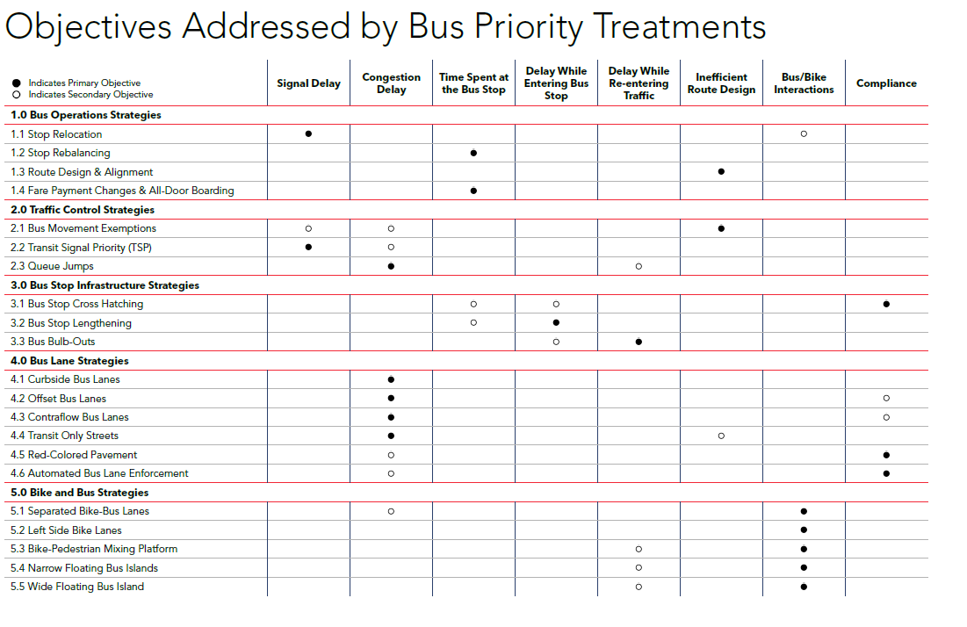
- Bus Operations
  - Stop Relocation
    - Change near-side to far-side stop
    - Can save 4 to 9 seconds per stop on average
    - Helpful for mixing with bike
  - Stop Rebalancing
    - 5 or less stops per mile for local service
    - 3 or less stops per mile for limited stop service
  - Route Design and Alignment
    - Eliminate turns
  - Fare Payment Changes and all-door boarding
- Traffic Control
  - Bus movement exemptions
    - Bus can turn where normal traffic is restricted
  - Transit signal priority
    - Most effective at intersections where buses experience high signal delay
    - Can save 5 to 15 seconds per intersection
  - Queue jumps
    - Opportunity for buses to move ahead of queued vehicles in a right turn lane and go ahead with an early green light
      - Need dedicated right turn lane and low right turn volumes
- Bus Stop Infrastructure
  - Bus Stop cross hatching
    - Installing cross hatching at bus stops helps to minimize illegal parking and loading in bus stops by increasing visibility of bus stop zone
    - Prioritize at locations with known parking regulation compliance issues
  - Bus Stop Lengthening
    - Longer bus stops can serve more buses simultaneously and allow buses to pull more closely to the curb, which can reduce delay resulting from buses waiting to enter occupied stops
    - Bus stops may need to be lengthened when they serve multiple routes, resulting in more than one bus needed to use the stop at the same time
    - Bus stop lengthening can eliminate spillback of buses onto the general traffic lane at bus stops, reducing general traffic delay
  - Bus bulb-out
    - Bus bulb-outs allow buses to board and alight passengers while remaining in the travel lane, thereby eliminating delay when re-entering traffic.
      - Add additional space for waiting riders
      - Alleviate sidewalk congestion
    - Useful at stops with delay from re-entering traffic, which are typically locations with traffic congestion and on streets where there is full-time parking
    - Appropriate in areas with high pedestrian traffic and narrow sidewalks where additional waiting space is needed
    - Treatment may also increase safety at locations with a history of collisions resulting from buses pulling into and out of the travel lane from the curbside bus stop
- Bus Lane
  - Curbside bus lanes
    - Corridors with frequent bus service and traffic congestion
    - Need adequate roadway width to serve a bus lane and a standard travel lane

  - Offset bus lanes
  - Contraflow bus lanes
  - Transit-only streets
  - Red-colored pavement
  - Automated bus lane enforcement

